1)Use the average function and calculate the average of all the three category of weight. (for this question use excel file named average 1
Output: 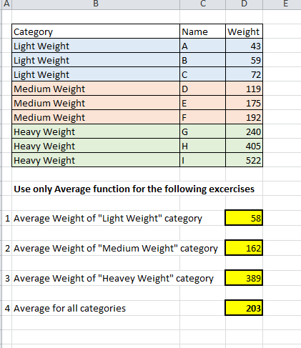

2) The excel file named Average 3, the table below contains precipitation measurement as measured in the Rochester NY area last year and we sampled 3 days in each of the first three months of 2018. Complete all the question in the file given.
Output:
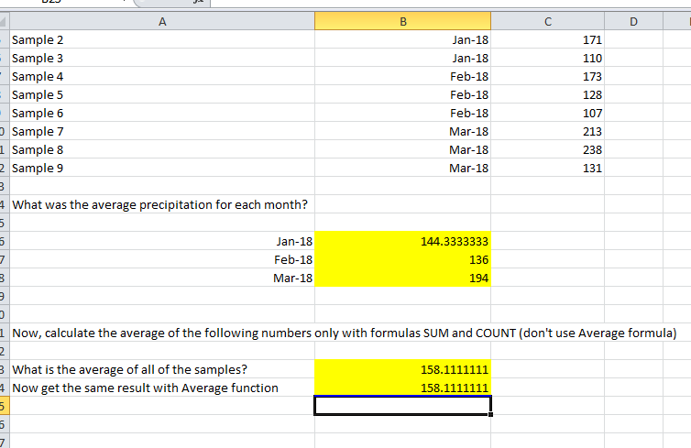
3) In excel file named Count 1, The table below shows survey responses; the respondents could use any value for their answers.
4) Answer all the questions using COUNT and COUNTA function.

Output:
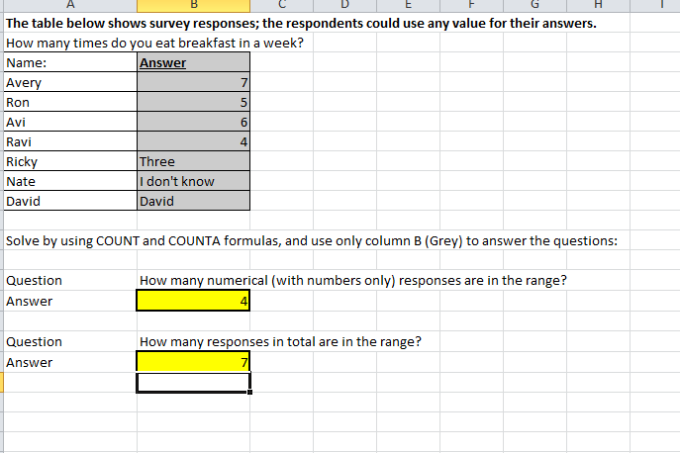
5) In excel file named COUNT 2, The following table represents a bank statement of ExcelMaster company. Column E shows the total dollar value amount of each of the accounts. Answer all the questions using COUNT and COUNTA function.
Output:
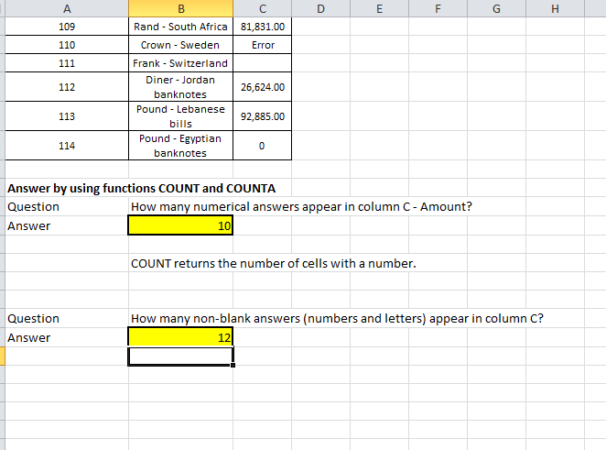

6) In excel file named COUNT 3, Solve all the question by using formulas COUNT, COUNTA and COUNTBLANK:
Output:
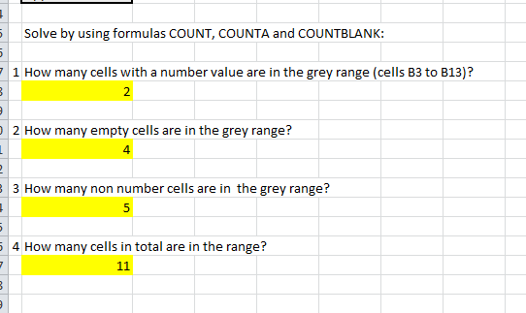

7) In excel file named HLOOKUP, solve all the question using HLOOKUP only.
Output:
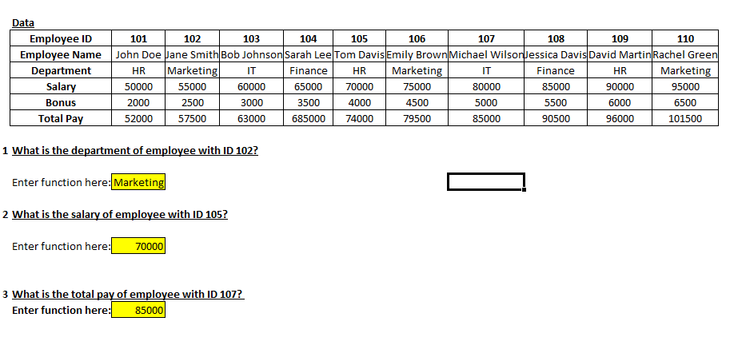
8) In excel file named IF 1, Table A contains names and their respective grades for Excel 101 Course. Complete column C using only IF formula.
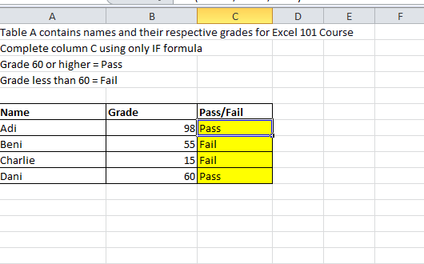

9) In excel file named IF 2, The following table is an extract from an accounting system that contains four journal entries. Check if column A's cells match column B's cell. if they match - return "match", otherwise return "no match".
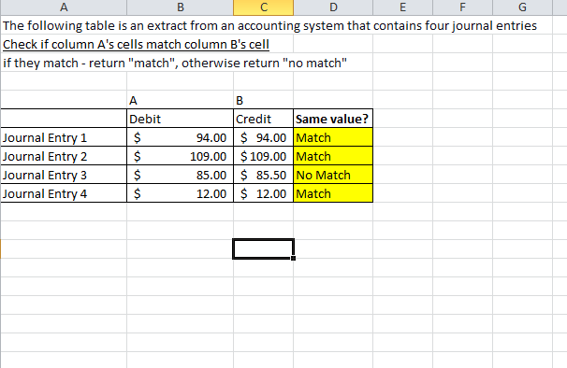

10) In excel file named IF 3, The table below contains details of high school student’s names and ages, use IF formula to complete columns D and E.If the student's age is 16 or above, he/she is eligible for a driver's license. Check if they are eligible or not. Answer in column D.
Output: 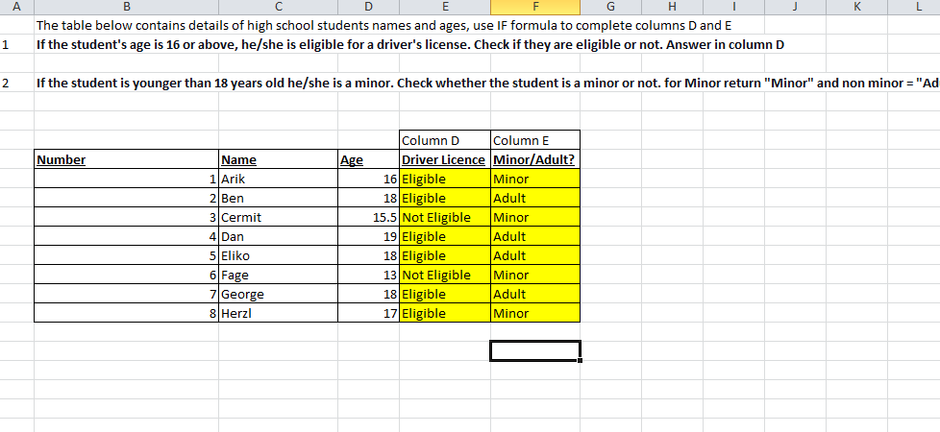
11) If the student is younger than 18 years old, he/she is a minor. Check whether the student is a minor or not. for Minor return "Minor" and nonminor = "Adult" answer in column E.
Output:

12) In excel file named IF 4, An A+ student gets 100% scholarship and non A+ gets 50% scholarship, the following table contains the names of students from 2024 class. Use IF function to calculate the scholarships' amounts each of them will get.
Output:
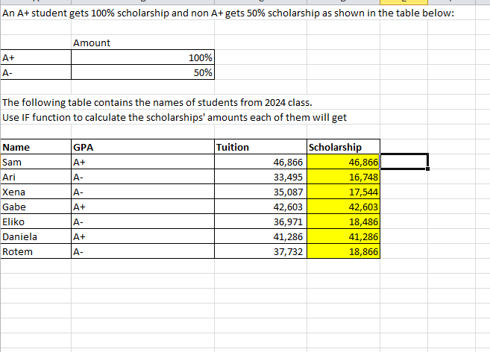

13) In excel file named Math 1, Use the following guidelines to calculate the statements given the file.
Output:
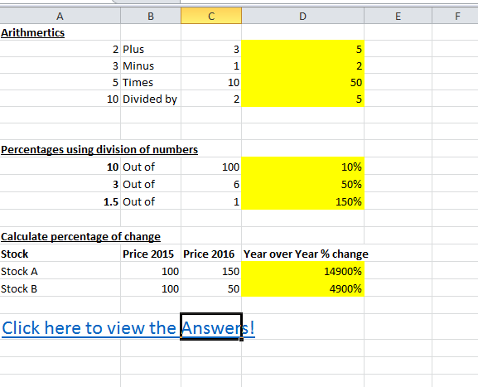

14) In excel file named MAX MIN 1, Use max, min and average formulas to answer all the following questions given in the file.
Output:
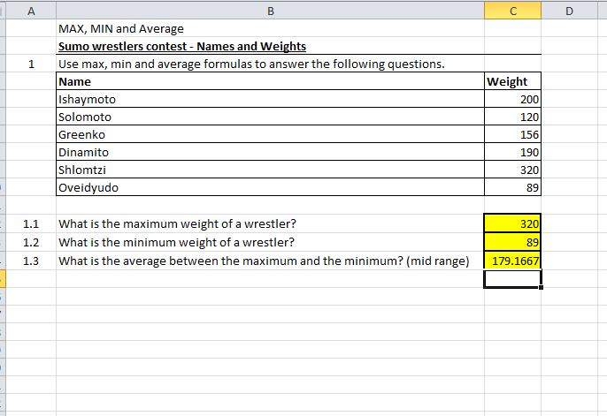

15) In the file named MAX MIN 2, The following table contains details about the scores of 4 students in a driving theory test. If a student fails at least one test - she or he needs to retake the course. Use IF and MAX/MIN to check if a student passed the test.
Output:
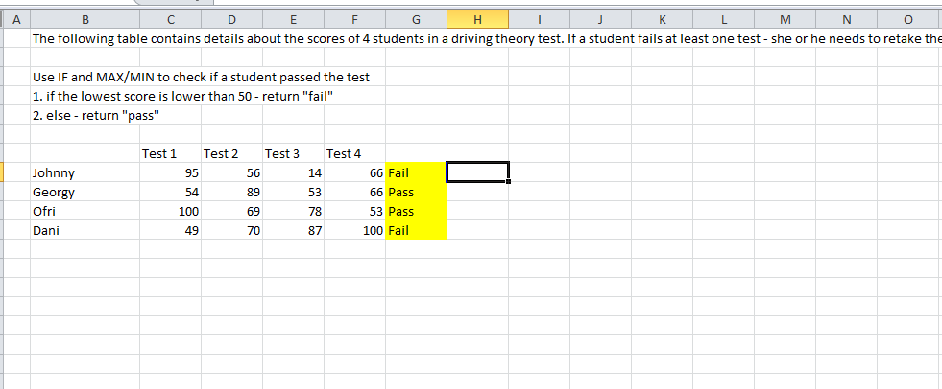

16) In the file named MAX MIN 3, IF at least one student got 99 points or more in a test - the test considered easy, Use MAX and IF to create a logic that checks if the test was "Easy" or not.
Output:
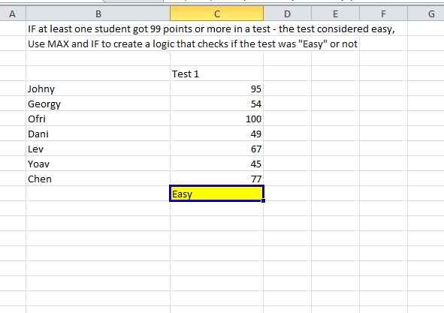
17) In the file named Nested IF 1, The school decided to use the following grade system: a. Grade higher or equal to 80 - Excellent b. Grade higher or equal to 60 but lower than 80 – Good c. Grade lower than 60 - Failed Complete all the task given in the file.
Output:
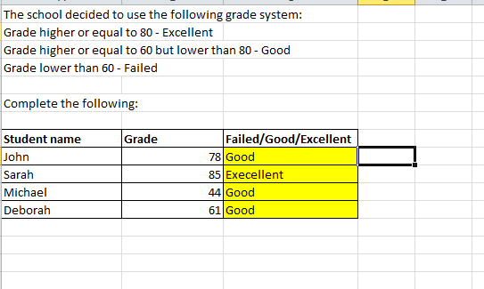
18) In the file named SUM 1, The following table includes ABC company's revenue by month. The company's CFO asked you to use SUM formula to calculate the total revenue for the year.
Output:
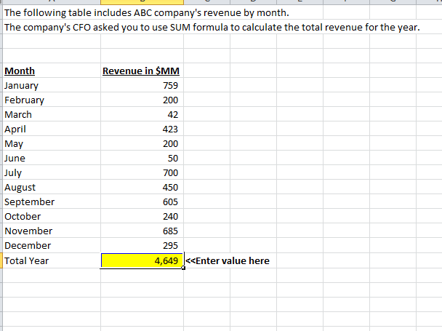

19) In the file named SUM 2, The following table represents daily costs by
Output:
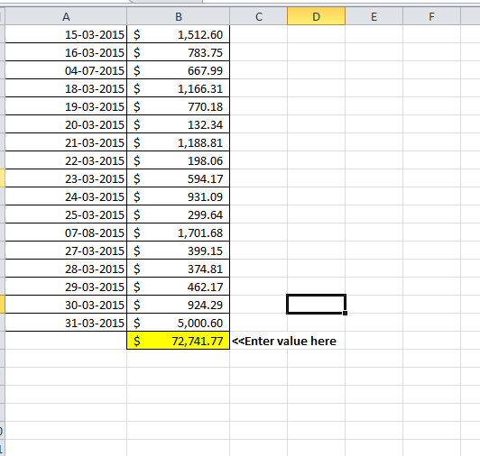

20) day for the first quarter of 2015. Calculate the total costs at the bottom of the table. Hint: to save time, use sum shortcuts.
Output
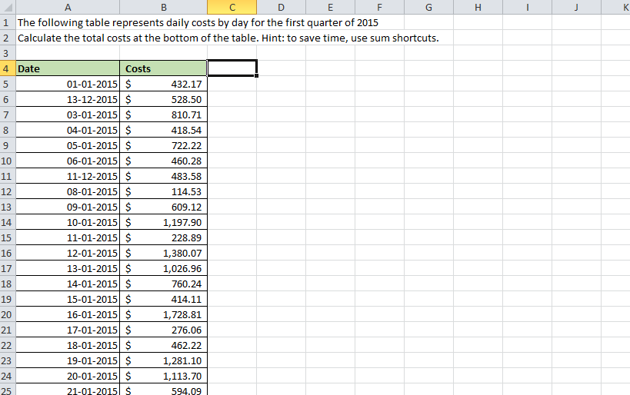

21) In the file named SUM 3, Find the number of residents for each of the following groups from the table below, complete all the question in the file.
Output:
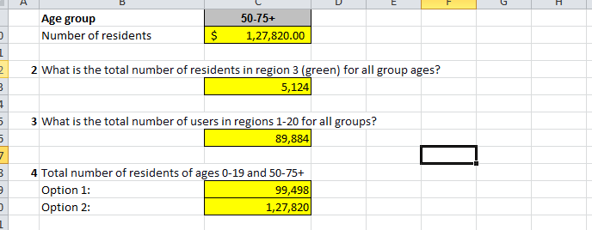
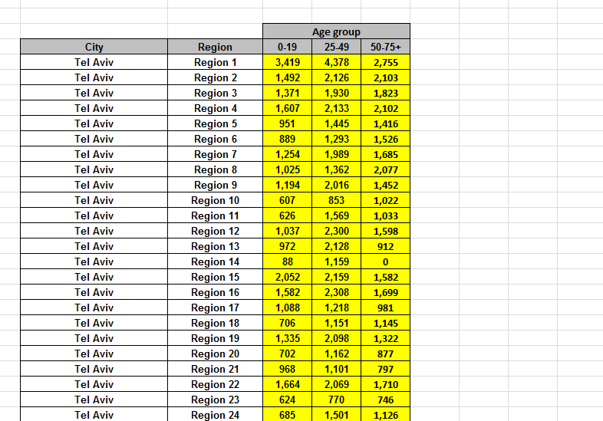
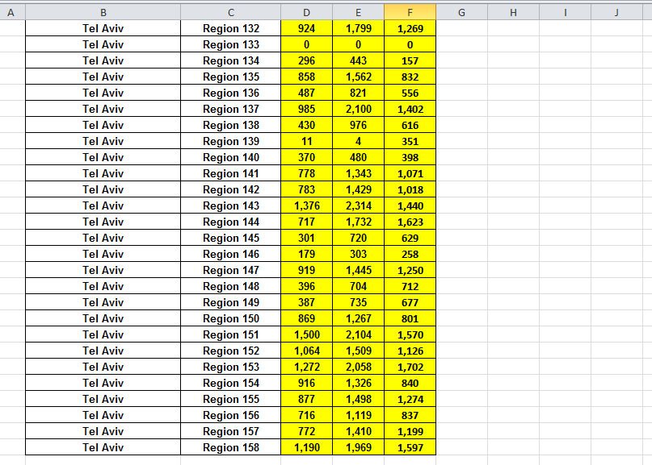
22) In the file named SUMIF 1, answer all the question given in the file.
Output:
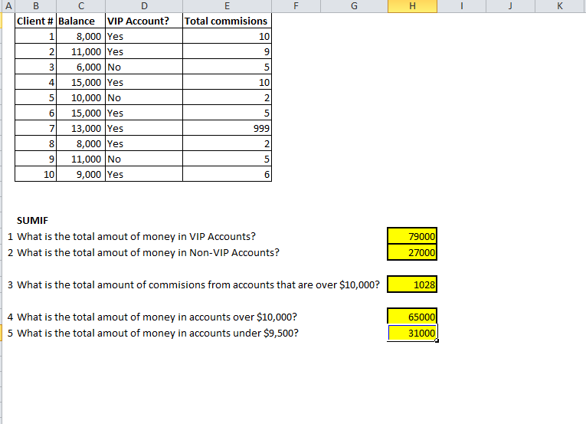

23) In the file named SUMIF 2, answer all the question given in the file based on table.
Output:
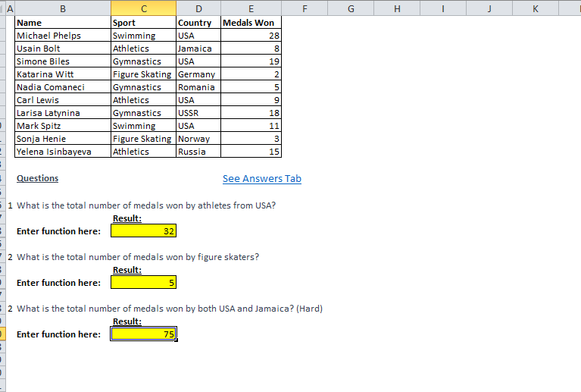

24) In the file named VLOOKUP APPROXIMATE MATCH, Retrieve the GBP: USD exchange rate for the following dates using VLOOKUP function, from the table in columns G-H. In case there is no exchange rate for a certain date entry, return the the last known rate for that day.
Output:
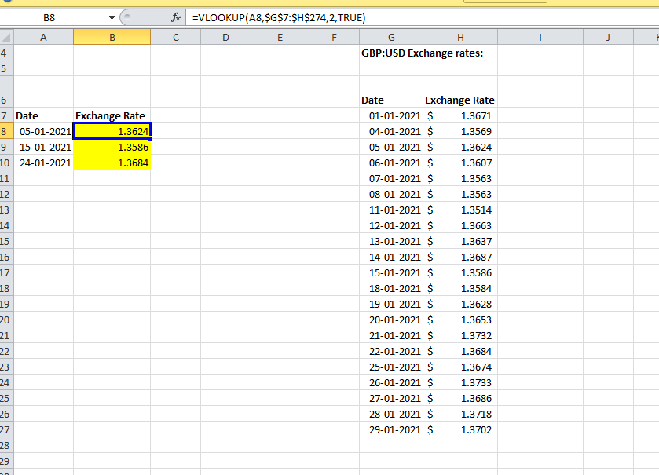

25) In the file named VLOOKUP 1, Below is a list of the employees whowork in your company: Answer all the question given in the file using vlookup function.
Output:
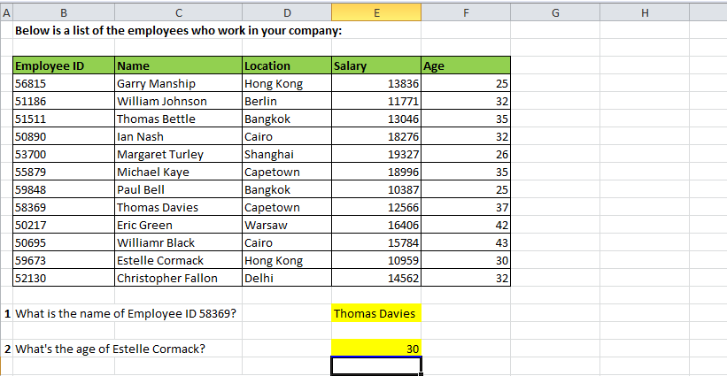
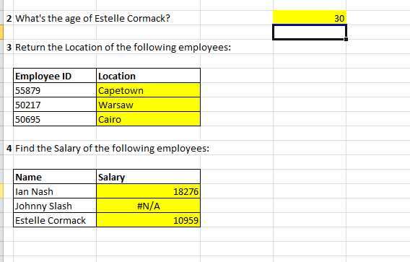
26)In the file named VLOOKUP 2a, according to the table, answer all the question given in the file using vlookup.
Output:
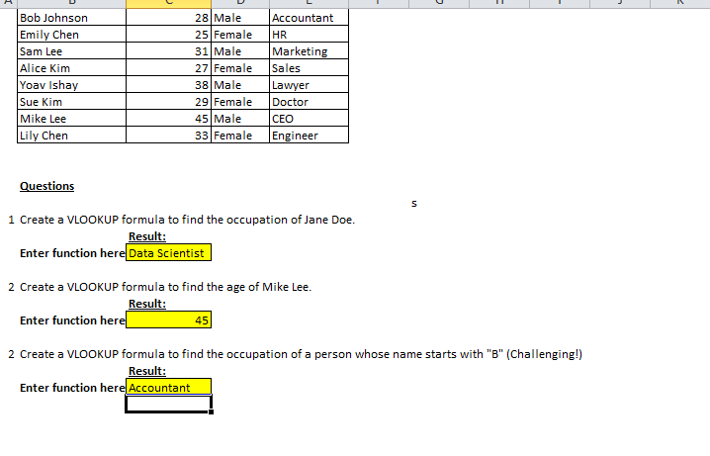
Question 27: - Our Main goal is to create a macro that will convert this CSV File into nice and clean table as shown below. (Use Macros file from GitHub)
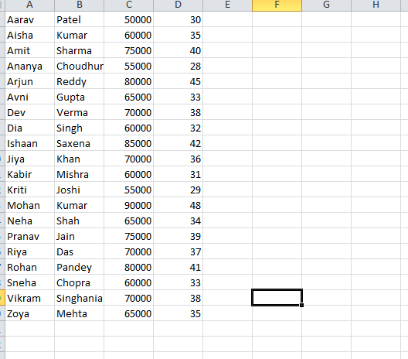

Question 28: - Our Main goal is to create a Macros that will convert this CSV File into nice and clean table as shown below. (Use VBA file from GitHub)
Output:
